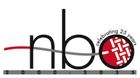

**NBO Tradition and Innovation in Basketry 12**

**July 22 – 27, 2025**

**NBO Silent Auction Donation Form**

|  |  |
| --- | --- |
| **Name of Donor:** |  |
| **Email:** |  |
| **Description of Item(s) Donated** |  |
| **Est.Value (optional)** |  |
| **Minimum Opening Bid (optional** |  |
| Please note: You may donate books, tools, etc., as well as baskets, earrings, pouches (etc.) you have made. When you are finished, be sure to “save” it and bring it with you to the conference. Thank you for your support of NBO and our scholarship programs! | |